I Don’t Paint
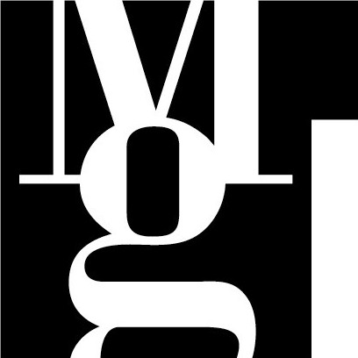
Tisková zpráva Press Release Release
Pražák Palace Cloister, Moravian Gallery in Brno, Husova 18
14 April – 5 June 2005

CURATOR OF THE EXHIBITION
Yvona Ferencová

Michal Kalhous (1967) is connected with a generation of photographers of the 1990´s. His often proclaimed relation to the works of Markéta Othová, Alena Kotzmannová, Lukáš Jasanský and Martin Polák, representatives of the so-called “no-photography”, does not signify an amalgamation in a monochrome stream of categorization; it only indicates at closeness of those artists and the frequency of being in a good mood. His high-scale black and white non-figurate photographs remind us of amateur snapshots. They are the records of private space; they mediate information about a particular situation. They also depict the seemingly marginal everyday reality, without need to stylization and improvement; they are mere statements.
There are presented two new cycles in the Moravian Gallery in Brno. They are the cycles, which the author himself calls “housing and touring”. Kalhous does not go beyond the borders of a given territory, he suspects that “….the balance is an estate of stagnant water”, he only leaves a detailed scanning of an intimate, in favour of a complex, which he attains by broadening the image field. Resulting nameless unimpressive photographs, which point out the quality of undivided state of things, are demonstration of fine author’s perception. They are one of the basic principles pf his testimony concerning the nature of world. Michal Kalhous does not paint, he takes photographs.
The auctorial exhibition of Michal Kalhous, which is organized by the Moravian Gallery in Brno, is a contribution to a dialogue about the photography medium of Czech art scene. It is topically commented by the exhibition Photography?? of the curator pair Pavel Vančát and Jan Freiberg, which took place in the House of the Lords from Kunštát (16 February – 3 April 2005), together with the exhibition of Alena Kotzmannová called Diamond Valley, Gallery 99 (10 March – 24 April 2005). This accidental appearance of three exhibitions which follow up one another, marks a significant testimony of a photographic medium, of its integrating among pluralistic stream of art, thanks to the ability to visualize the concept.
Y.F.

Michal Kalhous
Born 1967 in Valašské Meziříčí

Individual Exhibitions:
1995 Divadlo hudby (Music Thetre), Olomouc
1996 Gallery Fiducia, Ostrava
Minikinokavárna, Ostrava
Gallery Metro 70, Prostějov
1997 Gallery Velryba, Prague
1999 Gallery MXM, Prague
2000 Galerie U rudého vola, Brno
Gallery 761, Ostrava
2002 Václav Špála Gallery, Prague
2003 Music Theatre, Olomouc
2004 Emil Filla Gallery, Ústí nad Labem
Municipal Houses of Arts, České Budějovice
Gallery Fiducia, Ostrava
2005 Jiří Jílek Gallery, Šumperk

Collective Exhibitions:
1995 Zkušební provoz, Mánes, Prague
1997 Snížený rozpočet, Mánes, Prague
I. Zlínský salon mladých (Zlín Salon of Young), The House of Arts, Zlín
1998 Ostrava umjeni?, The House of Arts, Ostrava
1999 II. Nový zlínský salon (New Zlín Salon), The House of Arts, Zlín
Ostrava v Ústí (Ostrava in Ústí), Ústí nad Labem
1999 Akční Praha (Action Prague), Roxy, Prague
2000 Pocta Důl Michal, Důl Michal, Ostrava
Vidiny, Universal NoD, Prague
2001 V. Löffevr Gallery, Košice, Slovakia
ICING, Dunajvarosz, Hungary
Kolmo k ose II. (Perpendicularly to Axis II.), the House of Arts, Opava
2002 ICING, Václav Špála Gallery, Prague
Bienále mladých Zvon, GHMP (Biennale of Young, Bell) – Stone Bell House, Dům U kamenného zvonu, Prague
Čeští autsajdři (Czech Outsiders), Gallery Arsenal, Bialystok, Poland
2003 Wunderland, Muzeum těžby (Mining museum), Kiruna, Sweden
Čeští autsajdři, Dům slezské kultury (Silesian Culture House), Katovice, Poland
Wunderland, Hornické muzeum Landek (Mining Museum Landek), Ostrava
2004 Fotografie??, Gallery Klatovy-Klenová, Klatovy
2005 Fotografie??, Dům pánů z Kunštátu, Brno

CONTACT FOR MEDIA
Press Media: Mgr. Andrea Poláčková, spokesperson of MG, tel.: 532 169 174, 737 007 838 tisk@moravska-galerie.cz
Audiovisual Media: Bc. Klára Kubíčková, cultural and educational worker, tel.: 532 169 120,
777 054 134, klara.kubickova@moravska-galerie.cz

